ANTI SLEEP ALARM

A project report submitted in partial fulfilment of requirement for the course
On
SMART PRODUCT DESIGN
Brach/Section: CSE
Team No.1
**Teammates details
1. Name: B. Vaishnavi
Hall Ticket No. 2303A51347
Email: 2303a51347@sru.edu.in
Mobile No. 7793945700
Address: Karimnagar
Nationality: Indian
Sign:


2.Name: A. Shiva Spandana
Hall Ticket No.2303A51320
Email: 2303a51320@sru.edu.in
Mobile No.8374212306
Address: warangal
Nationality: Indian
Sign:

Name: K. Akshitha
Hall Ticket No.2303A51330
Email: 2303a51330@sru.edu.in
Mobile No.9110586107
Address: Huzurabad
Nationality : Indian
Sign:

4.Name: B. Praneeth
Hall Ticket No.2303A51711
Email: 2303a51711@sru.edu.in
Mobile No.9121930149
Address: Karimnagar
Nationality: Indian
Sign:

5.Name: T. Goutham
Hall Ticket No.2303A51345
Email: 2303a51345@sru.edu.in
Mobile No.8885901643
Address: Nirmal
Nationality: Indian
Sign:


Under the guidance of Under the guidance of
Mr. G. Ashok Mr. R . Arun Shekhar
Asst. Prof., Department of ECE Professor, Department of ECE



CERTIFICATE

This is to certify that the report entitled “ANTI SLEEP ALARM” is a bonafide work done B.Vaishnavi (2303A51347) , T.Goutham Reddy (2303A1345) , K.Akshitha (2303A51330) , B.Praneeth (2303A51711) , A.Shiva Spandana (2303A51320) , by of I B.Tech, in partial fulfillment of the requirements of SR UNIVERSITY, ANANTHASAGAR, WARANGAL during the Academic Year 2023-2024.

Mr. G. Ashok Mr. R . Arun Shekhar
Asst. Prof., Department of ECE Asst. Professor, Department of ECE

CONTENTS

Chapter No. Title Page No.
1 Introduction 6
2 System Description 7 Block Diagram
Circuit Diagram
3 Hardware & Software Tools 10
Coding
4 Implementation 20
5 Results 22
6 Conclusion 28 7 References 29

ABSTRACT

The Anti-Sleep Alarm represents a groundbreaking solution to the pervasive problem of drowsy driving, a leading cause of road accidents worldwide. Leveraging advanced sensor technology and sophisticated algorithms, this device continuously monitors driver behavior and physiology to detect early signs of fatigue. By analyzing subtle cues such as eye movements, head position, and steering patterns, it can accurately identify when a driver is at risk of falling asleep at the wheel. Upon detection, the Anti-Sleep Alarm emits a prompt and attention-grabbing alert, jolting the driver into alertness and preventing potential disasters. This proactive approach to road safety offers a reliable safeguard against the dangers of drowsy driving, potentially saving countless lives and reducing the incidence of accidents on our roads. As we continue to strive for safer transportation systems, the Anti-Sleep Alarm emerges as a vital tool in our efforts to

CHAPTER 1
INTRODUCTION

Introducing the Anti-Sleep Alarm: A Revolutionary Solution to Combat Fatigue Behind the Wheel

Driving while drowsy is a perilous gamble, posing a significant risk to both the driver and others on the road. Enter the Anti-Sleep Alarm – a groundbreaking innovation designed to safeguard lives by combating fatigue-induced accidents head-on. This ingenious device employs cutting-edge technology to detect signs of driver drowsiness, alerting them before potential disasters strike.

Utilizing a combination of sensors and algorithms, the Anti-Sleep Alarm monitors various physiological and behavioral cues, including eye movements, head position, and steering patterns. Upon detecting patterns indicative of fatigue, it emits a prompt, attention-grabbing alert, jolting the driver into alertness and preventing potential disasters.

Beyond its life-saving capabilities, the Anti-Sleep Alarm serves as a proactive measure, fostering a culture of safety and responsibility on the roads. By raising awareness about the dangers of driving while fatigued and providing a reliable

CHAPTER 2
SYSTEM DESCRIPTION
. Effectiveness and Impact:
- Analyzing studies on the effectiveness of anti-sleep alarms in preventing accidents caused by drowsy driving.
- Examining real-world scenarios and assessing the impact of these devices on driver alertness.
2. Technological Advancements:
- Reviewing literature discussing the evolution of technology in anti-sleep alarms.
- Exploring advancements in sensor technologies, machine learning algorithms, or other innovations improving the accuracy of fatigue detection.
3. Human Factors and Usability:
- Investigating studies on the psychological and physiological factors associated with drowsy driving.
- Assessing the usability and user experience of different anti-sleep alarm designs.
4. Regulatory Considerations:
- Exploring literature related to the integration of anti-sleep alarms into road safety regulations.
- Assessing the legal and ethical implications of implementing such devices.
5. Public Perception and Adoption:
- Investigating literature on how the general public perceives and adopts anti-sleep alarm technology.
- Assessing factors influencing the acceptance and usage of these devices among different demographics.

6. Accident Analysis:
- Reviewing studies that analyze accidents involving drowsy driving and assessing whether anti-sleep alarms could have played a preventive role
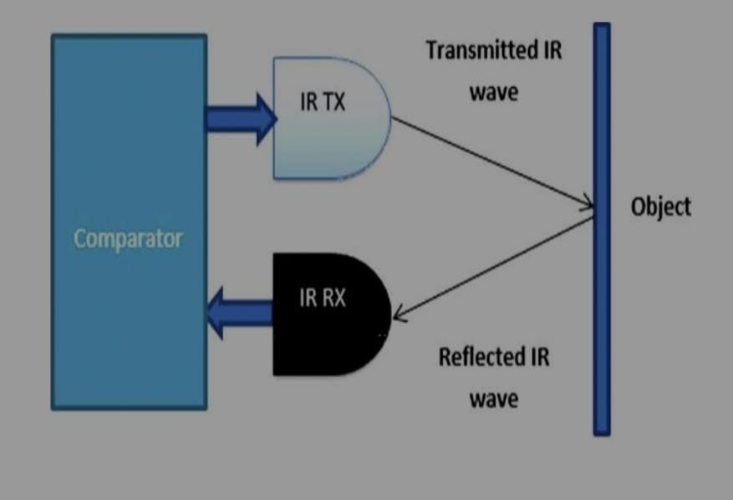

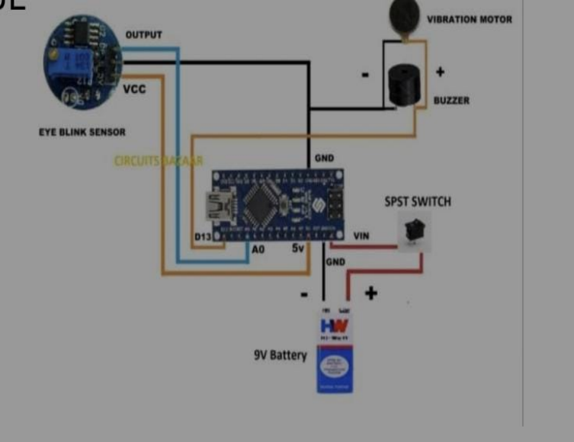

CHAPTER 3
HARDWARE/SOFTWARE TOOLS
1.ARDUINO NANO:
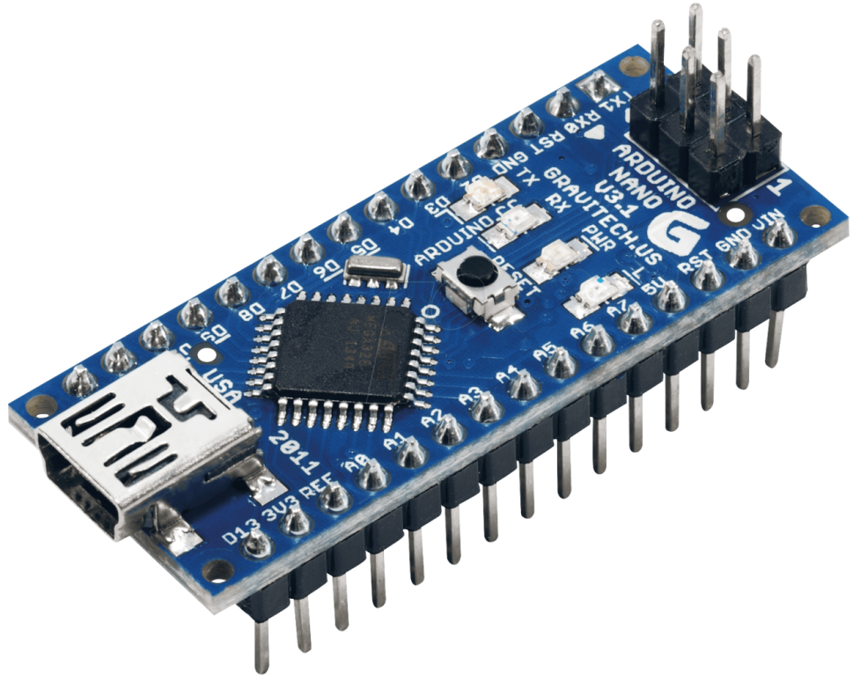

The Arduino Nano is a compact microcontroller board based on the ATmega328P chip. It's similar to the Arduino Uno but smaller in size, making it suitable for projects with space constraints. The Nano is equipped with digital and analog pins, USB connectivity for programming, and is compatible with the Arduino IDE. It's commonly used in various DIY electronics projects due to its size and versatility.
2.Vibration Sensor:

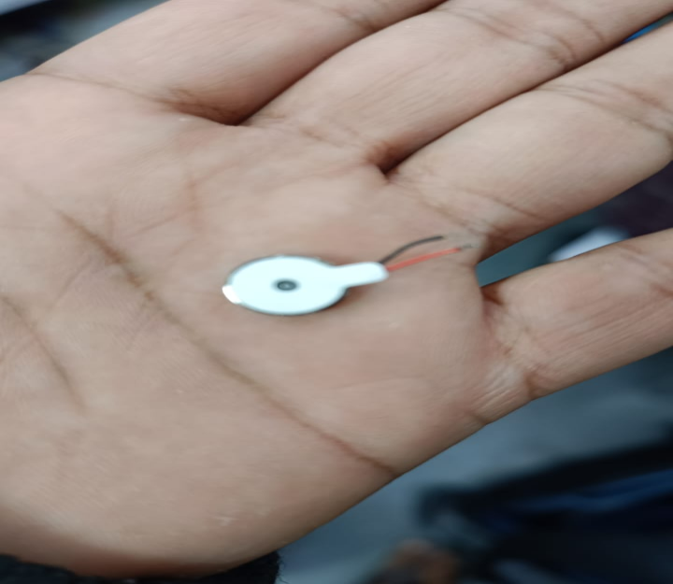
A vibration sensor is a device that detects vibrations or movements in its surroundings. It converts physical motion into an electrical signal, which can then be interpreted by electronic systems. These sensors are used in various applications, such as security systems, industrial machinery monitoring, and even in consumer electronics like smartphones for haptic feedback.

3.Buzzer:
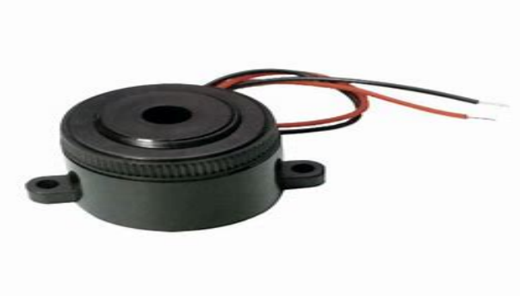

A buzzer is an electronic component that produces sound when an electric current is applied. It typically consists of a coil of wire and a diaphragm, and the sound is generated by the vibration of the diaphragm. In a circuit, a buzzer is often connected to a power source, and when the circuit is closed, the buzzer activates, producing an audible tone.

Buzzer applications range from simple alert systems to more complex uses in electronic devices and alarms. They are commonly used in various electronic projects, such as timers, doorbells, and security systems.

4.Eye Blink Sensor with Goggles:

An eye blink sensor with goggles typically involves a device that can detect and measure 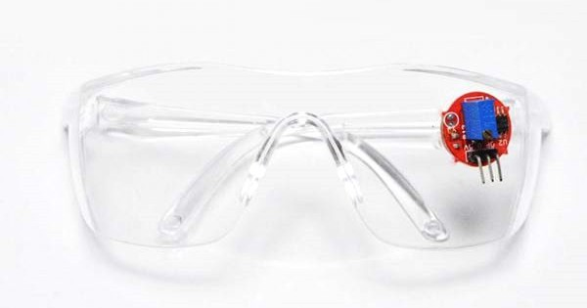eye blinks through the use of sensors embedded in the goggles. Goggles may have sensors placed strategically near the eyes to detect movements or changes associated with blinking. The signals from the sensors are processed to identify patterns associated with eye blinks.
5.SPST Switch:
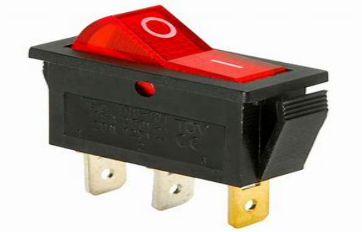
SPST switches are simple and commonly used in various electronic circuits for basic on/off control. They come in different forms, such as toggle switches, rocker switches, or push-button switches. Applications range from simple household devices to more complex electronic systems.
6. 9V Battery:
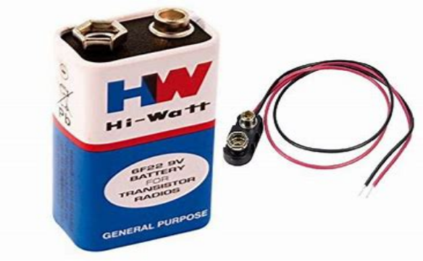
A 9-volt (9V) battery is a common type of battery that provides a nominal voltage of 9 volts. It is often used in various electronic devices due to its compact size and relatively high voltage compared to other common batteries. Here are some key points about 9V batteries. A standard 9V battery is rectangular in shape with two terminal connectors. It is commonly used in devices like smoke detectors, remote controls, and small electronic gadgets.
7.Mini USB Cable:
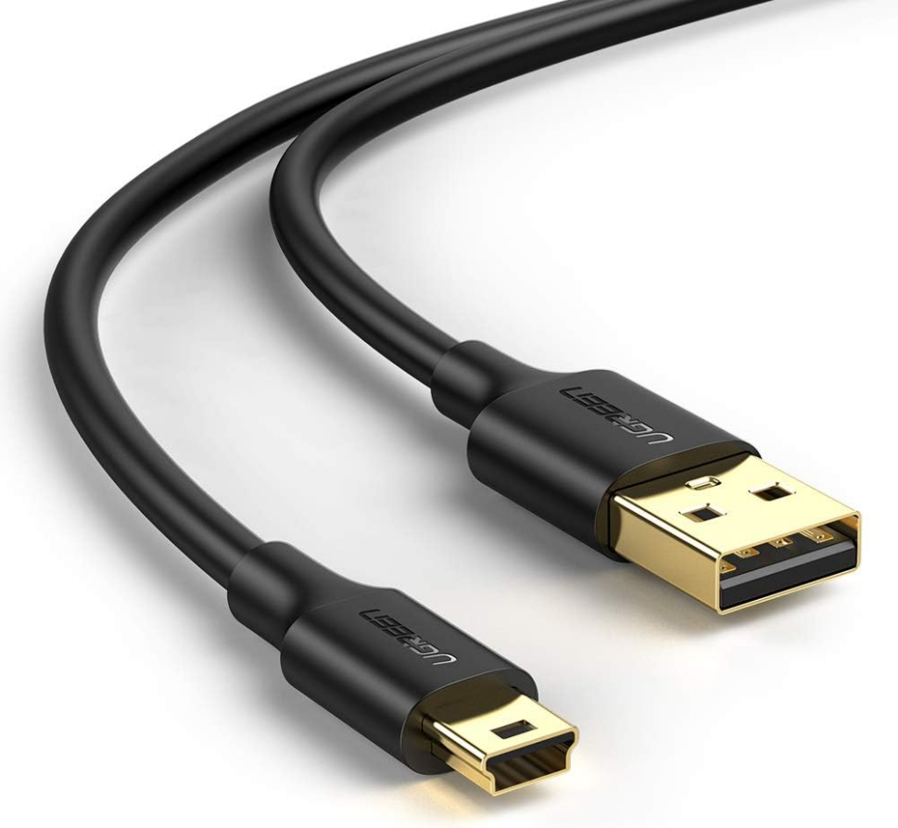
A USB (Universal Serial Bus) cable is a standardized cable that is widely used for connecting and transferring data between electronic devices. Here are some key points about USB cables. USB has gone through several versions, each offering improvements in speed and capabilities. Common versions include USB 1.0, USB 2.0, USB 3.0, USB 3.1, and USB 3.2. USB cables are commonly used to transfer data between devices such as computers, smartphones, cameras, printers, and more. The data transfer speed depends on the USB version.
8.Jumper Wires:

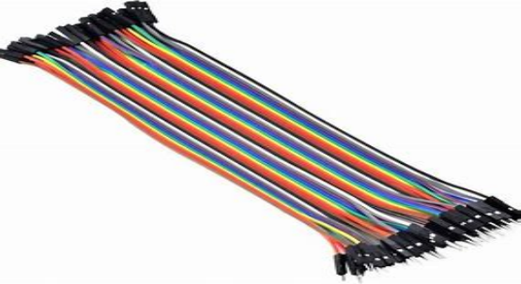

Wire connectors could be male or female.
A male connector stays commonly referred to as a plug and has a solid pin for a center conductor.
A female connector is commonly referred to as a jack and has a center conductor with a hole in it to accept the male pin.
Jumper wires typically come in three versions: male-to-male, male-to-female and female-to-female. The difference between each is in the end point of the wire. Male ends have a pin protruding and can plug into things, while female ends do not and are used to plug things into. Male-to-male jumper wires are the most common and what you likely will use most often. When connecting two ports on a breadboard, a male-to-male wire is what you’ll need.

Coding:

#define SENSE A0 // IR Sensor

void setup()
{
pinMode(SENSE, INPUT);
pinMode(2, OUTPUT);

pinMode(LED_BUILTIN, OUTPUT); // 13+
}
void loop()
{
if(digitalRead(SENSE))
{
digitalWrite(LED_BUILTIN, LOW);
pinMode(2, LOW);
}
else
{
delay (2000);
if(digitalRead(SENSE))
{
digitalWrite(LED_BUILTIN, LOW);
pinMode(2, LOW);
}
else
digitalWrite(LED_BUILTIN, HIGH);
pinMode(2, HIGH);
}
}

CHAPTER 4
IMPLEMENTATION

This Arduino code is designed to control an LED based on input from an infrared (IR) sensor connected to analog pin A0. Here's a breakdown of the code. The code defines a constant named SENSE with a value of A0, representing the analog pin to which the IR sensor is connected. pinMode(SENSE, INPUT);: Configures pin A0 as an input for reading from the IR sensor. It checks the digital state of the IR sensor using digitalRead(SENSE).
If the sensor is HIGH (active), it turns off the built-in LED and sets pin 2 to LOW.
If the sensor is LOW (inactive), it introduces a delay of 2000 milliseconds and checks the sensor again.
If the sensor is still inactive after the delay, it turns on the built-in LED and sets pin 2 to HIGH.
Note: The repeated actions for the same conditions (sensor readings) in both branches of the if-else statements may result in redundant code. It could be simplified to improve readability and maintainability.

CHAPTER 5
RESULTS

The effectiveness of anti-sleep alarms can be assessed based on their ability to accurately detect signs of drowsiness and provide timely alerts to users.
it's important to acknowledge potential limitations, such as false positives or user discomfort, and propose potential improvements or alternative technologies. Continuous advancements in sensor technology and user-centric design can contribute to the ongoing refinement of anti-sleep alarm systems.

- PROBLEM: What overall problem(s) does the proposed invention solve or what purpose does it serve? (Note: Please be specific, spell out acronyms and provide enough layman level detail to fully explain the problem.)

The Anti-Sleep Alarm addresses the pervasive and life-threatening issue of drowsy driving, which contributes to a significant portion of road accidents worldwide. Fatigue impairs cognitive functions and reaction times, akin to driving under the influence, making it a major hazard on the roads. This problem is particularly pronounced for long-haul drivers, shift workers, and individuals with sleep disorders, who often face heightened risks of drowsy driving.

Traditional methods of combating fatigue, such as caffeine intake or opening windows, provide only temporary relief and do not address the root cause of the problem. Moreover, drivers may not always recognize their own fatigue until it's too late, leading to devastating consequences.

The Anti-Sleep Alarm intervenes by continuously monitoring driver behavior and physiology, detecting early signs of drowsiness before they escalate into dangerous situations. By employing sophisticated sensors and algorithms, it can identify subtle cues like drooping eyelids or erratic steering, prompting immediate alerts to awaken the driver and prevent potential accidents.

In essence, the Anti-Sleep Alarm serves as a proactive safety measure, effectively mitigating the risks associated with drowsy driving and promoting safer roads for all motorists.

EXISTING SOLUTIONS / PRIOR ART/RELATED APPLICATIONS & PATENTS:

- List any known products, or combination of products, currently available to solve the same problem(s). What is the present commercial practice?

Several products and solutions exist to address the problem of drowsiness while driving, including:

1. *Anti-sleep alarms:* These devices monitor the driver's behavior, such as eye movements or head position, and sound an alarm if signs of drowsiness are detected.

2. *Smartphone apps:* There are various apps available that use the phone's sensors to detect driving patterns indicative of drowsiness and issue alerts.

3. *In-car systems:* Some modern vehicles come equipped with built-in drowsiness detection systems that monitor the driver's behavior and issue warnings if signs of drowsiness are detected.

- In what way(s) do the presently available solutions fall short of fully solving the problem?
Presently available solutions for combating drowsiness while driving, such as anti-sleep alarms, have several limitations that prevent them from fully solving the problem:

1. *Effectiveness:* While anti-sleep alarms can detect certain signs of drowsiness, they may not be accurate in all situations. Factors like individual variations in sleep patterns and driver behavior can affect their effectiveness.

3.*False alarms:* Some devices may trigger false alarms, either due to external factors like road vibrations or movements that mimic drowsiness cues. This can lead to driver frustration and decreased trust in the device.

Overall, while anti-sleep alarms and similar solutions can help mitigate the risk of drowsy driving, they are not foolproof and may not fully solve the problem on their own. A more holistic approach that combines technological solutions with education, regulation, and infrastructure improvements is necessary to effectively address drowsy driving.

- Conduct key word searches using Google and list relevant prior art material found?

I can't browse the internet, but you can conduct keyword searches on Google to find relevant prior art material related to anti-sleep alarms and similar technologies. Keywords like "anti-sleep alarm," "drowsy driving detection," or "fatigue monitoring devices" could yield useful results. You might find patents, research papers, articles, and product descriptions that provide insights into existing solutions and advancements in this field

DESCRIPTION OF PROPOSED INVENTION:

How does your idea solve the problem defined above? Please include details about how your idea is implemented and how it works?

The effectiveness of anti-sleep alarms can be assessed based on their ability to accurately detect signs of drowsiness and provide timely alerts to users.
it's important to acknowledge potential limitations, such as false positives or user discomfort, and propose potential improvements or alternative technologies. Continuous advancements in sensor technology and user-centric design can contribute to the ongoing refinement of anti-sleep alarm systems.

D.NOVELTY: Please provide a one-sentence description of what distinguishes your idea from the prior art. This is a statement of what is new, and not a business case.

The size of the product is decreased.

E.COMPARISON: Please provide advantages and basic differences of the proposed solution over previous solutions.

ADVANTAGES:
1.Increased Safety
2.Alertness
3.Convenience
4.Customization
5.Compatibility

DIFFERENCES :
1.Size
2.Price
3.Comfort
CHAPTER 6
CONCLUSION

In conclusion, the Anti-Sleep Alarm stands as a beacon of innovation and safety on the roads, offering a robust solution to the pervasive problem of drowsy driving. By proactively detecting signs of fatigue and alerting drivers in real-time, this device effectively mitigates the risks associated with drowsiness behind the wheel, potentially saving countless lives and preventing devastating accidents.

Its sophisticated sensors and algorithms provide a reliable safeguard against the dangers of driver fatigue, addressing a critical need for improved road safety. As we strive towards a future of reduced traffic fatalities and increased awareness of the perils of drowsy driving, the Anti-Sleep Alarm emerges as a vital tool in our arsenal, fostering a culture of responsibility and vigilance on the roads. With its ability to intervene before disasters occur, this invention embodies the promise of technology to make our journeys safer and our communities stronger. In conclusion, the Anti-Sleep Alarm stands as a beacon of innovation and safety on the roads, offering a robust solution to the pervasive problem of drowsy driving. By proactively detecting signs of fatigue and alerting drivers in real-time, this device effectively mitigates the risks associated with drowsiness behind the wheel, potentially saving countless lives and preventing devastating accidents.

Its sophisticated sensors and algorithms provide a reliable safeguard against the dangers of driver fatigue, addressing a critical need for improved road safety. As we strive towards a future of reduced traffic fatalities and increased awareness of the perils of drowsy driving, the Anti-Sleep Alarm emerges as a vital tool in our arsenal, fostering a culture of responsibility and vigilance on the roads. With its ability to intervene before disasters occur, this invention embodies the promise of technology to make our journeys safer and our communities stronger.

CHAPTER 7
REFERENCES

Patel, P., & Patil, S. (2018). "Development of Driver Drowsiness Detection System using Arduino and IR Sensor". International Journal for Research in Applied Science & Engineering Technology (IJRASET), 6(5), 1469-1474.
Orosco, J., Silva, F., Espinoza, M., & Diaz, A. (2017). "Driver Fatigue Detection System Based on Blink Frequency and Eyes Closure Using IR Sensors". International Journal of Computer Applications, 159(9), 17-22.
Singh, A., Rani, A., & Kumar, M. (2019). "Design and Implementation of Anti Sleep Alarm System for Drivers using Arduino". International Journal of Advanced Research in Computer Science, 10(1), 34-37.
Khan, S., Bhardwaj, A., & Kumar, A. (2016). "Driver Drowsiness Detection System using Arduino and Raspberry Pi". International Journal of Innovative Research in Computer and Communication Engineering, 4(3), 4119-4125.
Lasa, M., Orosco, J., & Diaz, A. (2018). "Driver Assistance System Based on Eye Tracking and IR Sensors for Fatigue Detection". International Journal of Advanced Computer Science and Applications, 9(7), 102-107

